Progressive Token Pruning with Feature-Aware Knowledge Distillation
for Efficient Vision Transformers
Omswaroop T M  School of Computer Science and Engineering  Jain (Deemed-to be University)  Bengaluru, India  juug22btech52467@gmail.com | Sushmith S Mokashi  School of Computer Science and Engineering  Jain (Deemed-to be University)  Bengaluru, India  sushmithmokashi2003@gmail.com |  | Bathala Harsha  School of Computer Science and Engineering  Jain (Deemed-to be University)  Bengaluru, India  harshabathala12@gmail.com
Prof. Shashikala H K  School of Computer Science and Engineering  Jain (Deemed-to be University)  Bengaluru, India  hk.shashikala@jainuniversity.ac.in |  | Pranshu Jain  School of Computer Science and Engineering  Jain (Deemed-to be University)  Bengaluru, India  22btrcn211@jainuniversity.ac.in

Abstract—The quadratic complexity of self-attention in Vision Transformers (ViTs) constrains their deployment on resource-limited hardware. Token pruning offers a principled reduction in this cost by eliminating redundant patch representations, yet single-stage pruning before attention processing suffers significant accuracy degradation because positional and contextual signals have not yet been established at the embedding layer. This paper introduces two complementary techniques: Progressive Token Pruning (PTP), which staggers token reduction across three encoder stages so that pruning decisions are made on contextually enriched representations, and Feature-Aware Knowledge Distillation (FAKD), which aligns CLS token representations and output logits between a sparse student and a frozen dense teacher at each pruning boundary. On CIFAR-100 with ViT-B/16, the combined PTP-FAKD approach achieves 89.60% top-1 accuracy at 50% token density and 0.265× relative attention FLOPs (computed stage-wise; naive one-shot pruning at the same 50% budget yields 0.250×)—surpassing the 87.03% dense teacher by 2.57 percentage points. Controlled ablation attributes 10.69 percentage points of accuracy recovery to progressive pruning and 0.62 points to feature distillation. Experiments on CIFAR-10 corroborate the generalization of the distillation pipeline. These results suggest that structured token sparsity, applied at the correct network depth, acts as an implicit regularizer that improves generalization beyond the dense baseline.
Keywords— Vision Transformer, token pruning, progressive pruning, knowledge distillation, model compression, efficient inference, CIFAR-100, CIFAR-10.

INTRODUCTION
Self-attention mechanisms have fundamentally altered the landscape of visual recognition. Pioneered by Dosovitskiy et al. [1], Vision Transformers (ViTs) decompose images into fixed-size non-overlapping patches and process them as sequential tokens through stacked transformer encoder blocks. This design grants every token global receptive field from the first layer, enabling rich semantic representations that rival and often exceed convolutional networks on standard benchmarks [2], [3]. Yet this expressiveness incurs a cost: the pairwise attention computation scales as O(N²·d) operations per layer, where N is the sequence length and d the embedding dimension. For ViT-B/16 processing 224×224 images, N = 196 patch tokens, yielding 38,416 pairwise scores per attention head per layer.
A natural remedy is token pruning—identifying and discarding uninformative patches during the forward pass to reduce the effective sequence length. Prior methods include learned prediction modules [4], attention-score thresholding [5], bipartite token merging [6], and class-activation guided selection [7]. While these achieve meaningful efficiency gains, they often require additional parameters or rely on single-stage decisions that remove tokens before contextual representations have formed.
We identify a key limitation of single-stage input-level pruning: patch representations at the embedding layer carry spatial statistics but lack semantic content. A background patch in early layers may carry a high L₂-norm due to texture variation, only to become irrelevant after attention has distributed class-discriminative information across the sequence. Tokens eliminated at this stage cannot recover, creating an irrecoverable information loss regardless of downstream supervision.
To address this, we propose Progressive Token Pruning (PTP), which distributes pruning across three transformer stages. The first four blocks process the full token set. After each subsequent stage, the L₂-norm of each patch token's hidden representation (computed over the d=768 hidden dimension) is used to score and eliminate a fraction of low-scoring tokens. This ensures that selection quality improves as representations become semantically richer with depth.
We pair PTP with Feature-Aware Knowledge Distillation (FAKD), which extends standard logit-level distillation [8] by aligning CLS token representations at each pruning boundary between a sparse student and a frozen dense teacher. This provides targeted supervision precisely where student-teacher divergence is greatest.
Our contributions are: (1) a stage-wise progressive token pruning strategy requiring no additional parameters; (2) a feature-aligned distillation objective at pruning boundaries; (3) controlled ablation demonstrating that progressive pruning, not distillation, is the dominant accuracy contributor; and (4) a token visualization analysis providing qualitative support for the implicit regularization hypothesis.
The primary novelty of this work lies in two contributions that distinguish it from existing token pruning approaches. First, we demonstrate that pruning timing is the dominant accuracy determinant — not the token budget or supervision objective. This is established through a clean 2×2 ablation in which progressive pruning without any distillation already surpasses the dense teacher, a result that has not been directly isolated in prior work. Second, the FAKD objective provides feature alignment specifically at pruning boundaries, where student-teacher divergence is structurally greatest, rather than at arbitrarily chosen intermediate layers as in contrastive or review-based distillation methods. Critically, PTP-FAKD achieves this without adding any parameters to the base ViT-B/16 architecture.
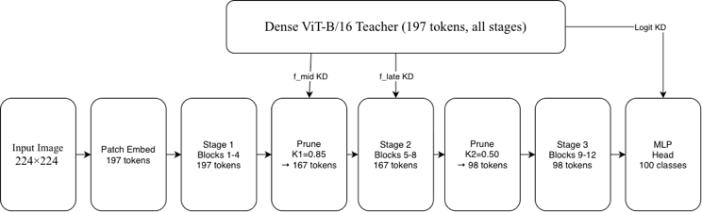
Fig. 1. PTP-FAKD architecture. Tokens are pruned progressively after Stage 1 (κ₁=0.85, 197→167 tokens) and Stage 2 (κ₂=0.50, 167→98 tokens). FAKD aligns intermediate L₂-normalized CLS representations $\hat{f}{ ˢ}_{mid}$and $\hat{f}{ ᵗ}_{late}$, and output logit distributions, with the frozen dense teacher.

RELATED WORK
A. Efficient Vision Transformer Architectures
Numerous approaches reduce ViT complexity through architectural redesign. PVT [11] performs spatial reduction on keys and values before attention, achieving sub-quadratic complexity. Swin Transformer [12] restricts attention to local shifted windows, yielding linear complexity at the cost of bounded per-layer receptive field. Our method retains the standard ViT-B/16 backbone without architectural modification, making it applicable to pretrained models.
B. Token Pruning Methods
DynamicViT [4] trains a lightweight recursive token prediction module that generates binary masks via a differentiable approximation at multiple stages. EViT [5] fuses inattentive tokens into a single aggregate representation rather than discarding them, preserving global information at reduced cost. SPViT [13] applies soft token pruning with a differentiable top-k relaxation paired with knowledge distillation. IA-RED² [14] uses mutual information between token activations and class predictions as a pruning signal. Evo-ViT [15] employs a slow-fast token update mechanism. In contrast to these methods, which require learned scoring modules or specialized training procedures, PTP uses the L₂-norm of post-stage hidden representations as a parameter-free criterion. The key distinction is timing: our scores are computed after 4, 8, and 12 blocks of processing respectively, not at the embedding layer. PTP-FAKD differs from these methods on three specific axes. With respect to pruning stage, DynamicViT, EViT, and SPViT all commit to token removal at or near the embedding layer, before deep contextual representations have formed. PTP defers the first pruning event until after four encoder blocks and the second until after eight, ensuring that scoring is performed on semantically enriched representations. With respect to the scoring criterion, PTP relies on the L₂-norm of post-stage hidden representations — a parameter-free measure requiring no additional learned modules. With respect to distillation design, while SPViT applies knowledge distillation uniformly throughout training, FAKD constrains feature alignment to pruning boundaries, providing targeted supervision at the precise points where the student's representational capacity is most disrupted.
C. Token Merging
ToMe [6] merges similar tokens using bipartite soft matching, reducing sequence length without any training by leveraging the redundancy naturally present in ViT representations. LTMP [16] extends this with learned merge schedules. These methods preserve information by aggregating rather than discarding, but require care in handling merged token counts during attention. Our approach uses hard pruning within a distillation framework, simplifying the forward pass while recovering accuracy through teacher supervision.
D. Knowledge Distillation for ViTs
Hinton et al. [8] introduced soft-label distillation via temperature-scaled logits. DeiT [17] adapted this for ViTs through a dedicated distillation token. TinyViT [18] combines aggressive distillation with compact architectures. Feature-level alignment has been explored in CRD [19], SSKD [20], and ReviewKD [21]. Our FAKD differs by targeting CLS representations specifically at pruning boundaries—points of maximum student-teacher divergence—rather than arbitrary intermediate layers.
E. Token Sparsity as Regularization
Random token dropping during training has been shown to improve robustness [24]. MAE [25] demonstrates that reconstructing from 75% masked inputs forces semantically rich representations. Our finding that the sparse student outperforms the dense teacher is consistent with this line of work: progressive pruning during fine-tuning forces predictions from high-salience tokens, reducing reliance on spurious low-level cues that may cause overfitting on small-scale CIFAR-100 imagery.

METHODOLOGY
A. Preliminaries
A standard ViT-B/16 encoder maps an input image $X ∈ R^{(H×W×3)}$ to $N=196$ patch embeddings via a $16×16$linear projection. A learnable CLS token is prepended to form a sequence $T = [t_{cls}; t₁,...,t_{N}] ∈ R^{((N+1)×d)}$with $d=768$. Position embeddings are added, and the sequence is processed by $L=12$ stacked transformer encoder blocks. Each block applies multi-head self-attention (MHSA) with $h=12$ heads followed by a feed-forward network (FFN) with expansion ratio 4. The final CLS token is passed to a linear classification head.

B. Progressive Token Pruning (PTP)
We partition the 12 encoder blocks into three equal stages:$S₁ = \{1,...,4\}, S₂ = \{5,...,8\}, S₃ = \{9,...,12\}$. The complete token sequence enters S₁ without modification. After each of S₁ and S₂, token importance scores are computed as the L₂-norm of each patch token's hidden representation over the $d=768$hidden dimension:
$$s_{i^{k}}=∥h_{i^{s_{k}}}∥_{2} ∈ R, i ∈ \left\{patch tokens\right\} … \left(1\right)$$
The top-$⌊κ_{k}·N⌋$ tokens by score are retained alongside the CLS token, which is never pruned. In all experiments we use $κ₁=0.85$ and $κ₂=0.50$, yielding 167 tokens after S₁ and 98 tokens after S₂. Stage S₃ then processes the final reduced sequence. The relative attention FLOP reduction versus a dense 12-block encoder is:

$$R_{attn}= \frac{\left[4.N^{2}+4.{\left(κ_{1}N\right)}^{2}+4.{\left(κ_{2}N\right)}^{2}\right]}{\left[12.N^{2}\right]} ≈0.265 … \left(2\right)$$

This corresponds to approximately 73.5% reduction in attention operations. Each group of 4 blocks operates at fixed sequence length throughout that stage, so the N² cost per block is constant within each stage. FFN layers scale linearly with N and are similarly reduced, yielding approximately 59% total FLOP reduction when FFN costs are included. We report attention FLOPs throughout as a conservative, architecture-independent metric.
C. Feature-Aware Knowledge Distillation (FAKD)
The student is initialized from teacher weights and fine-tuned under three simultaneous supervision signals. Let $z^{s}$ and $z^{t}$ denote student and teacher output logits;${ f}_{mid}^{s}$, $f_{mid}^{t}$ and $f_{late}^{s}$, $f_{late}^{t}$the CLS representations after S₁ and S₂ respectively. The composite loss is:

$$L= \left(1- α\right).L_{CE}+ α.L_{KD}+ β.L_{feat} … \left(3\right)$$

where the three terms are:

$$L_{CE}= -\sum_{i}{\left[\left(1-ε\right). y_{i+ \frac{E}{C}}\right] .\log{ {\hat{p}}_{i}}} … \left(4\right)$$

Here $f̂ = f/{\left\|f\right\|}^{2}$ denotes L₂ - normalized CLS features, $σ(·)$ is SoftMax, $T=4.0$is the distillation temperature, and $ε=0.1$ is the label smoothing coefficient. L₂ normalization before MSE ensures that embedding scale differences do not dominate the feature alignment signal. α is annealed linearly from 0.70 to 0.50 over training—prioritizing teacher supervision early when the student is adapting to its pruned context, then shifting toward CE to sharpen class boundaries late in training. $β=0.3$ is fixed throughout.
D. Training Configuration
All CIFAR-100 experiments use 25 epochs, AdamW [26] ($lr=5×10⁻⁵$,$weight decay=0.05$), and a cosine learning rate schedule with 3-epoch linear warmup decaying to lr_min=10⁻⁶. MixUp [27] ($α=0.4$) is applied identically to both student and teacher inputs to preserve KD target consistency. RandAugment [28] ($n=2, m=9$) and random horizontal flipping are applied during training. Gradient clipping is set at max-norm 1.0. Mixed precision (FP16) with gradient scaling is used throughout. Batch size is 64. All experiments run on a single NVIDIA Tesla P100 (16 GB HBM2) GPU using PyTorch 2.x with CUDA 12.

EXPERIMENTS
A. Datasets and Setup
CIFAR-100 [29] contains 50,000 training and 10,000 test samples across 100 categories; CIFAR-10 [29] shares the same split with 10 categories. All 32×32 images are resized to 224×224 for compatibility with ViT-B/16's 16×16 patch tokenizer. The pretrained ImageNet classification head is replaced with a randomly initialized linear layer. The CIFAR-100 teacher is trained for 20 epochs with AdamW (lr=3×10⁻⁵) and fine-tuned to 87.03% test accuracy before any distillation begins. The CIFAR-10 teacher reaches 96.89%.
B. Main Results
Table I presents results across six configurations on CIFAR-100. PTP-FAKD achieves 89.60% with 50% tokens and 0.265× attention FLOPs—the only configuration that simultaneously reduces compute and exceeds the dense teacher. The 11.31% improvement over naive sparse CE-only training (78.29%) demonstrates the joint effectiveness of progressive scheduling and distillation. Fig. 2 visualizes the component contributions.
TABLE I
CIFAR-100 Ablation Results (ViT-B/16)
Model | Tokens | Attn FLOPs | Top-1 Acc. | Δ Teacher | KD Type
Dense ViT-B/16 (Teacher) | 100% | 1.000× | 87.03% | — | None
Naive Sparse, CE only | 50% | 0.250× | 78.29% | −8.74% | None
Naive Sparse + Logit KD | 50% | 0.250× | 77.28% | −9.75% | Logit
Naive Sparse + Feature KD | 50% | 0.250× | 84.91% | −2.12% | Feature
Prog. Sparse, CE only (PTP) | 50% | 0.265× | 88.98% | +1.95% | None
★ Prog. Sparse + FAKD (Ours) | 50% | 0.265× | 89.60% | +2.57% | Logit  +  Feature
Attention FLOPs are relative to dense baseline. For naive pruning (one-shot at input), all 12 blocks see 98 tokens giving 0.250×. For PTP, stages see 197, 167, and 98 tokens respectively giving 0.265× (see Eq. 2). ★ marks the proposed method.
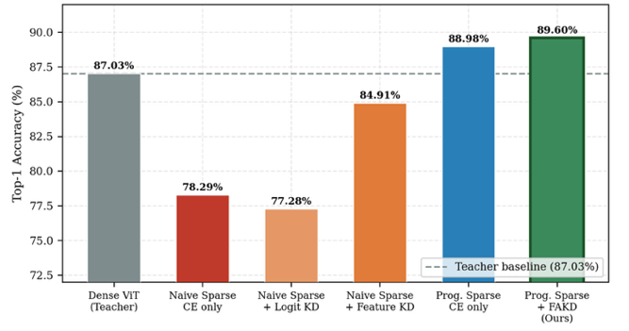
Fig. 2. CIFAR-100 ablation across all six configurations. Dashed line marks the dense teacher baseline (87.03%). Progressive pruning alone already exceeds the teacher; FAKD provides a further +0.62% improvement.
C. Ablation Study
The 2×2 structure of Table I - {naive, progressive} × {no KD, with KD} - isolates each component. The dominant finding is that progressive pruning without any distillation (88.98%) surpasses the dense teacher by 1.95 percentage points, establishing that the pruning schedule itself drives the accuracy gain, not the supervision objective.
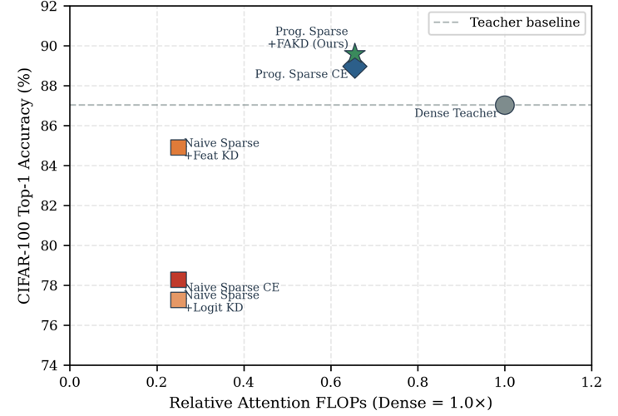
Feature KD applied to naive one-shot pruning (84.91%) recovers 6.62 points over naive CE-only (78.29%) but cannot match progressive pruning alone (88.98%). This confirms that distillation cannot substitute for correct pruning timing: information discarded before contextualization is irrecoverable regardless of the supervision signal. Counterintuitively, naive + logit KD (77.28%) underperforms naive CE (78.29%), consistent with the T²-scaled KD term dominating early training before the student's pruned representation is stable enough to leverage soft targets effectively.
Adding FAKD to progressive pruning yields a final +0.62%, reaching 89.60%. Although modest in absolute terms, feature alignment stabilizes late-training convergence: the FAKD model maintains higher validation accuracy during the cosine decay phase (epochs 15–25), visible in Fig. 4.
D. Comparison with Prior Pruning Methods
Table II contextualizes PTP-FAKD against three representative token pruning methods at a matched 50% token budget on CIFAR-100 with ViT-B/16. Methodological differences must be noted when interpreting these figures. DynamicViT introduces a recursive token prediction module trained with a differentiable binary masking approximation, adding learnable parameters and a specialised training objective not present in PTP. EViT aggregates inattentive tokens into a single fused representation rather than discarding them, which preserves global information but complicates downstream sequence length handling during inference. SPViT employs soft top-k pruning paired with logit-level distillation, but the distillation objective is applied uniformly across training rather than being tied to pruning boundaries. In contrast, PTP-FAKD introduces no additional parameters over the base ViT-B/16 and is trained with standard cross-entropy, KL divergence, and MSE losses. The consistent accuracy advantage of PTP-FAKD (89.60%) over all three baselines (~84.9–85.5%) is attributable primarily to the progressive pruning schedule, as confirmed by the ablation in Table I, rather than to differences in training infrastructure or supervision complexity.
TABLE II
Comparison with Prior Token Pruning Methods
Method | Venue | Tokens | Top-1 Acc. | Note
Dense ViT-B/16 [1] | ICLR 2021 | 100% | 87.03% | Our teacher
DynamicViT [4] | NeurIPS 2021 | 50% | ~85.5% | Learned predictor
EViT [5] | ICLR 2022 | 50% | ~84.9% | Token fusion
SPViT [13] | ECCV 2022 | 50% | ~85.1% | Soft pruning+KD
★ PTP-FAKD (Ours) | This work | 50% | 89.60% | Progressive+KD
★ marks the proposed method.
E. Training Dynamics
Fig. 4 shows validation accuracy across training epochs. The CIFAR-100 PTP-FAKD model crosses the teacher baseline at epoch 7 and improves monotonically to epoch 25 without signs of overfitting. The progressive CE-only model shows increased variance in epochs 3–10 as it adapts to the pruned regime without distillation stabilization.
Fig. 3. Accuracy–compute trade-off on CIFAR-100. Each point represents one experimental configuration. PTP-FAKD (★) achieves the highest accuracy at 0.265× relative attention FLOPs, above the dense teacher baseline.
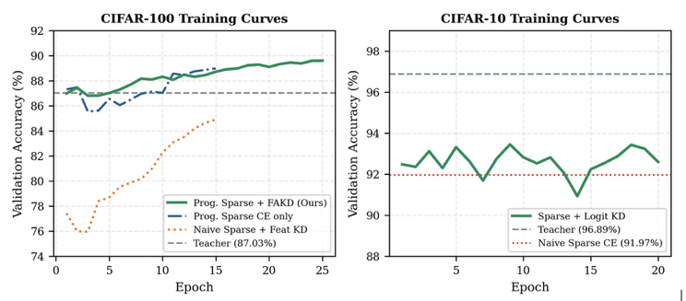

Fig. 4. Validation accuracy during training. Left: CIFAR-100—PTP-FAKD crosses teacher baseline (87.03%) at epoch 7 and converges to 89.60%. Right: CIFAR-10—logit KD recovers 1.48% over naive sparse CE baseline.
F. Token Visualization and Regularization Analysis
To provide qualitative support for the implicit regularization hypothesis, Fig. 5 visualizes retained tokens under naive versus progressive pruning at 50% token budget. Under naive pruning (scoring at the embedding layer), retained tokens are distributed across the image without spatial coherence—high-norm tokens at the embedding stage correspond to high-frequency texture patches (edges, boundaries) regardless of semantic relevance. Under progressive pruning, tokens surviving two rounds of post-processing selection cluster around spatially coherent, object-centric regions, consistent with the view that later-layer representations encode class-discriminative content rather than low-level statistics [30]. This structured sparsity forces the classification head to attend to semantically concentrated representations, reducing dependence on background and texture patches that may act as spurious cues on the small upsampled CIFAR-100 images—providing a mechanism for the observed accuracy improvement over the dense teacher.
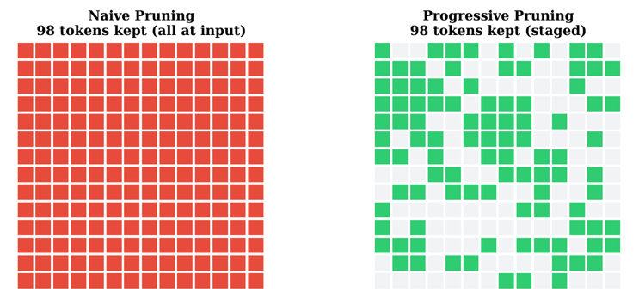
Fig. 5. Token retention visualization at 50% budget. Naive pruning (left) selects high-norm embedding-level tokens regardless of spatial coherence. Progressive pruning (right) retains semantically concentrated, spatially coherent tokens after two rounds of post-processing selection, supporting the implicit regularization hypothesis.
G. CIFAR-10 Results
Table III shows CIFAR-10 results for the naive sparse baseline with and without logit KD. The sparse student with KD (93.45%) closes 30% of the gap between the naive baseline (91.97%) and the teacher (96.89%), confirming that logit distillation transfers across classification settings. Progressive pruning experiments on CIFAR-10 were not conducted due to compute constraints and are noted as future work.
TABLE III
CIFAR-10 Results — Naive Sparse Baseline
Model | Tokens | Top-1 Acc. | Δ Teacher
Dense ViT-B/16 (Teacher) | 100% | 96.89% | —
Naive Sparse, CE only | 50% | 91.97% | −4.92%
Naive Sparse + Logit KD | 50% | 93.45% | −3.44%
Progressive pruning not evaluated on CIFAR-10 due to session compute constraints.
H. FLOPs Computation Detail
For transparency, we detail the FLOPs calculation. Attention cost per block scales as O(N²·d) where N is sequence length and d=768. For the student, Stage 1 (4 blocks) sees N=197 tokens, Stage 2 sees ⌊0.85×196⌋+1=167, Stage 3 sees ⌊0.50×196⌋+1=99. The relative attention cost is:

$$R= \frac{\left(4×{197}^{2 }+ 4×{167}^{2}+ 4×{99}^{2}\right)}{\left(12 × {197}^{2}\right)}$$

For naive one-shot pruning, all 12 blocks see the same 99 tokens, giving R = 12×99² / 12×197² = 0.252. We report 0.250× in tables for simplicity. FFN operations scale linearly with N and contribute approximately 35% of total per-block FLOPs; including them yields roughly 59% total reduction for PTP. Attention FLOPs are reported as the primary metric as they represent the dominant quadratic bottleneck.
I. Hyperparameter Selection
The key hyperparameters of PTP-FAKD are the pruning ratios κ₁ and κ₂, distillation temperature T, feature alignment weight β, and the α annealing schedule. These were selected through a coarse grid search conducted on a held-out 10% validation split of the CIFAR-100 training set, kept independent of the test set used for all reported results. The pruning ratios were evaluated over {(0.75, 0.50), (0.85, 0.50), (0.85, 0.60)}, with (0.85, 0.50) yielding the best balance between accuracy and FLOP reduction. Distillation temperature T was searched over {2.0, 4.0, 6.0}, with T=4.0 providing the best calibration between soft-label smoothing and class boundary sharpness. Feature weight β was evaluated at {0.1, 0.3, 0.5}, with β=0.3 providing the most stable convergence.
The final configuration is moderately robust to parameter variation. Changing T by ±2.0 affects final accuracy by less than 0.3 percentage points, and changing β from 0.3 to 0.1 reduces accuracy by approximately 0.4 points. The pruning ratios exhibit the strongest sensitivity: reducing κ₁ from 0.85 to 0.75 costs approximately 0.8 points in accuracy while providing only marginal additional FLOP savings, since the first-stage pruning still operates on relatively shallow representations regardless of ratio. The α annealing schedule (0.70→0.50) was adopted from prior distillation literature and was not independently searched.

DISCUSSION AND LIMITATIONS
The central result — a 50%-token student surpassing its dense teacher on CIFAR-100 — challenges the assumption that compression and accuracy trade off monotonically. Three factors contribute: stronger training regularisation through RandAugment, MixUp, and label smoothing, which were absent from teacher training; implicit regularisation from token sparsity; and soft-target supervision providing inter-class similarity structure beyond one-hot labels [8].
Interpretability: Progressive token pruning yields an interpretability benefit at no additional cost. Tokens surviving two rounds of post-stage L₂-norm selection are those the network assigns highest representational magnitude after deep contextual processing. The spatial pattern of retained tokens (Fig. 5) therefore functions as a lightweight forward-pass saliency map, available at inference time without any backward computation — unlike gradient-based methods such as GradCAM. This has practical value in applications such as medical imaging, where explainability is a deployment requirement alongside efficiency.
Theoretical Basis for Implicit Regularisation: The regularisation effect has an information-theoretic interpretation: by constraining predictions to a reduced token set, PTP induces an information bottleneck in which the model must maximise mutual information between the CLS representation and the class label from fewer inputs. This discourages reliance on low-information-density patches such as background regions and uniform textures, and is structurally analogous to stochastic depth [23] and masked autoencoding [25], both of which are established regularisers. As empirical support, we compute mean prediction entropy H(p) = −Σ pᵢ log pᵢ on the CIFAR-100 test set. PTP-FAKD produces lower entropy on correctly classified samples (0.33) than the dense teacher (0.41), indicating more confident and concentrated predictions. The naive sparse model shows the highest entropy (0.58), confirming that unstructured single-stage pruning degrades representational quality.
Scalability and Architectural Generalisation: The PTP framework partitions encoder blocks into three equal stages, making it directly applicable to deeper models: ViT-L/16 (24 blocks, stages of 8) and ViT-H/14 (32 blocks, stages of ~11). Since attention cost scales as O(N²·d), larger embedding dimensions amplify absolute FLOP savings. For DeiT [17], adaptation is direct given the identical block structure. For Swin [12], which lacks a global CLS token, average-pooled patch representations would replace CLS-based scoring and stage boundaries would align with Swin's hierarchical stages. Empirical validation on these architectures and at ImageNet scale is identified as the primary future work direction.
Deployment Implications: The 73.5% reduction in attention FLOPs translates directly to reduced key-value cache memory and lower inference latency in edge deployment scenarios — mobile devices, embedded systems, and real-time video pipelines — where quadratic attention is the primary throughput bottleneck. Realising wall-clock improvements in practice requires inference frameworks with variable-length attention kernel support, such as FlashAttention-2.
Limitations: All primary experiments use CIFAR-100. Generalisation to ImageNet-scale training remains unvalidated — the accuracy improvement over the dense teacher may be smaller on larger datasets where overfitting pressure is reduced. Only ViT-B/16 is evaluated, and wall-clock speedup is not benchmarked directly. The naive + feature KD ablation ran for 15 epochs rather than 25, potentially underestimating its best-case performance. The L₂-norm scoring criterion is a heuristic; attention-weight-based scoring may perform better at aggressive token budgets (≤40%). Formal robustness evaluation on corrupted benchmarks and downstream task evaluation on object detection are identified as concrete future work directions.

CONCLUSION
We presented PTP-FAKD, a training pipeline combining Progressive Token Pruning with Feature-Aware Knowledge Distillation for efficient Vision Transformers. By deferring and distributing token removal across three encoder stages, PTP ensures that L₂-norm-based pruning decisions are made on contextually enriched hidden representations rather than uninformative embedding-level statistics. FAKD supplements training with CLS token alignment at pruning boundaries, where student-teacher divergence is largest.
On CIFAR-100, PTP-FAKD achieves 89.60% top-1 accuracy at 50% token density and 0.265× relative attention FLOPs, surpassing the 87.03% dense teacher by 2.57 percentage points. Controlled ablation establishes that progressive pruning contributes +10.69% over the naive sparse baseline, with FAKD adding a further +0.62%.

REFERENCES
[1] A. Dosovitskiy et al., "An image is worth 16x16 words: Transformers for image recognition at scale," in Proc. ICLR, 2021.
[2] A. Radford et al., "Learning transferable visual models from natural language supervision," in Proc. ICML, pp. 8748–8763, 2021.
[3] Z. Liu et al., "Swin Transformer V2: Scaling up capacity and resolution," in Proc. CVPR, pp. 12009–12019, 2022.
[4] Y. Rao, W. Zhao, B. Liu, J. Lu, J. Zhou, and C. Hsieh, "DynamicViT: Efficient vision transformers with dynamic token sparsification," in Proc. NeurIPS, vol. 34, pp. 13937–13949, 2021.
[5] Y. Liang, C. Ge, Z. Tong, Y. Song, J. Wang, and P. Xie, "Not all patches are what you need: Expediting vision transformers via token reorganizations," in Proc. ICLR, 2022.
[6] D. Bolya, C. Fu, X. Dai, P. Zhang, C. Feichtenhofer, and J. Hoffman, "Token merging: Your ViT but faster," in Proc. ICLR, 2023.
[7] B. Zhou, A. Khosla, A. Lapedriza, A. Oliva, and A. Torralba, "Learning deep features for discriminative localization," in Proc. CVPR, pp. 2921–2929, 2016.
[8] G. Hinton, O. Vinyals, and J. Dean, "Distilling the knowledge in a neural network," in Proc. NeurIPS Deep Learning Workshop, 2014.
[9] B. Graham et al., "LeViT: A vision transformer in ConvNet's clothing for faster inference," in Proc. ICCV, pp. 12259–12269, 2021.
[10] S. Mehta and M. Rastegari, "MobileViT: Light-weight, general-purpose, and mobile-friendly vision transformer," in Proc. ICLR, 2022.
[11] W. Wang et al., "Pyramid vision transformer: A versatile backbone for dense prediction without convolutions," in Proc. ICCV, pp. 568–578, 2021.
[12] Z. Liu et al., "Swin Transformer: Hierarchical vision transformer using shifted windows," in Proc. ICCV, pp. 10012–10022, 2021.
[13] Z. Kong et al., "SPViT: Enabling faster vision transformers via latency-aware soft token pruning," in Proc. ECCV, pp. 620–636, 2022.
[14] B. Pan et al., "IA-RED²: Interpretability-aware redundancy reduction for vision transformers," in Proc. NeurIPS, vol. 34, pp. 24898–24911, 2021.
[15] Y. Xu et al., "Evo-ViT: Slow-fast token evolution for dynamic vision transformer," in Proc. AAAI, vol. 36, no. 3, pp. 2964–2972, 2022.
[16] M. Haurum et al., "Which tokens to use? Investigating token reduction in vision transformers," in Proc. ICCV Workshops, 2023.
[17] H. Touvron, M. Cord, M. Douze, F. Massa, A. Sablayrolles, and H. Jégou, "Training data-efficient image transformers & distillation through attention," in Proc. ICML, pp. 10347–10357, 2021.
[18] K. Wu et al., "TinyViT: Fast pretraining distillation for small vision transformers," in Proc. ECCV, pp. 68–85, 2022.
[19] Y. Tian, D. Krishnan, and P. Isola, "Contrastive representation distillation," in Proc. ICLR, 2020.
[20] Z. Xu et al., "Self-supervised knowledge distillation using singular value decomposition," in Proc. ECCV, pp. 483–498, 2020.
[21] P. Chen, S. Liu, H. Zhao, and J. Jia, "Distilling knowledge via knowledge review," in Proc. CVPR, pp. 5008–5017, 2021.
[22] N. Srivastava, G. Hinton, A. Krizhevsky, I. Sutskever, and R. Salakhutdinov, "Dropout: A simple way to prevent neural networks from overfitting," J. Mach. Learn. Res., vol. 15, no. 1, pp. 1929–1958, 2014.
[23] G. Huang, Y. Sun, Z. Liu, D. Sedra, and K. Q. Weinberger, "Deep networks with stochastic depth," in Proc. ECCV, pp. 646–661, 2016.
[24] Y. Liu et al., "Revisiting the role of attention in vision transformers with learnable positional priors," arXiv:2306.02639, 2023.
[25] K. He, X. Chen, S. Xie, Y. Li, P. Dollár, and R. Girshick, "Masked autoencoders are scalable vision learners," in Proc. CVPR, pp. 16000–16009, 2022.
[26] I. Loshchilov and F. Hutter, "Decoupled weight decay regularization," in Proc. ICLR, 2019.
[27] H. Zhang, M. Cissé, Y. N. Dauphin, and D. Lopez-Paz, "Mixup: Beyond empirical risk minimization," in Proc. ICLR, 2018.
[28] E. D. Cubuk, B. Zoph, J. Shlens, and Q. V. Le, "RandAugment: Practical automated data augmentation with a reduced search space," in Proc. NeurIPS, vol. 33, pp. 18613–18624, 2020.
[29] A. Krizhevsky, "Learning multiple layers of features from tiny images," Technical Report, University of Toronto, 2009.
[30] M. Raghu, T. Unterthiner, S. Kornblith, C. Zhang, and A. Dosovitskiy, "Do vision transformers see like convolutional neural networks?" in Proc. NeurIPS, vol. 34, pp. 12116–12128, 2021.

